**Name:Aarya gandhi**

**Class: D15B**

**Roll: 15**

**Advance Devops-5**

**Aim: To install and configure terraform on windows/linux**

**Theory:**

Terraform is an infrastructure as code (IaC) tool that allows you to build, change,  and version infrastructure safely and efficiently. This includes low-level  components such as compute instances, storage, and networking, as well as high level components such as DNS entries, SaaS features, etc.

Terraform can manage infrastructure on multiple cloud platforms. Terraform's  state allows you to track resource changes throughout your deployments. You can  commit your configurations to version control to safely collaborate on infrastructure. Terraform plugins called providers let Terraform interact with  cloud platform and other services via their application programming interfaces  (APIs).

**Steps to install terraform**

1. Go to<https://developer.hashicorp.com/terraform/install?product_intent=terraform>

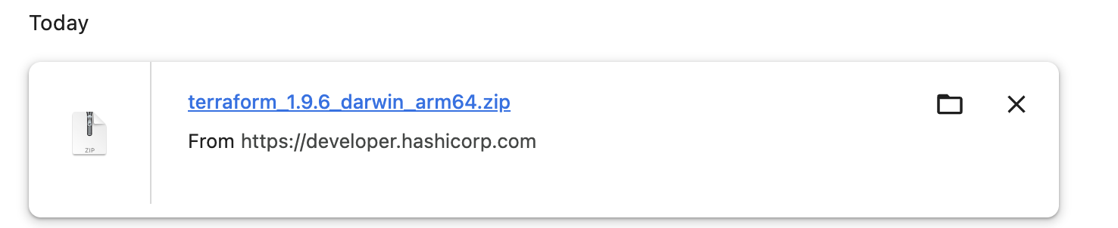

1. Unzip the folder

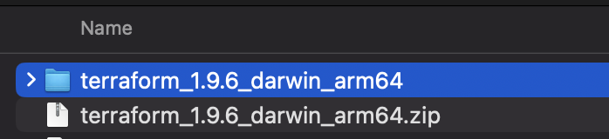

1. Execute the Terraform file and grant permissions to execute it on the system and check the system

